**Individual Research Assignments Part I. Equity Research**

**Step (1) Business Analysis**

* (1.A) Your own insight: 3 examples of the best (most competitive) products/services.
  + iPhone
  + Apple Services
  + Others (very close)
    - Mac
    - iPad
    - Wearables
  + <https://247wallst.com/consumer-electronics/2021/01/13/these-are-apples-best-selling-products/>
  + <https://www.businessofapps.com/data/apple-statistics/>
  + <https://www.investopedia.com/apple-s-5-most-profitable-lines-of-business-4684130>
  + <https://www.investopedia.com/markets/quote?tvwidgetsymbol=aapl>
* (1.B) Major Value Drivers (including assets, cash flow, and growth options).
  + Assets – growth of assets – balance sheet; morningstar, finance.yahoo
    - E.g. total assets (see any changes over time):
      * The total assets of AAPL increase over time, as shown in the balance sheet below.
      * 
      * <https://finance.yahoo.com/quote/AAPL/balance-sheet?p=AAPL>
    - E.g. proportion of fixed assets (or NPPE), current assets, intangible assets to total assets, etc.:
      * NPPE increases over time, as shown in the balance sheet below.
      * 
      * Current assets decrease over time, as shown in the balance sheet below.
      * 
      * There are no intangible assets, as shown in the balance sheet below.  
        
      * <https://www.morningstar.com/stocks/xnas/aapl/financials>
  + CF – cash flow statement (FCF is positive?); morningstar, finance.yahoo FCF in cash flow statement:
    - FCF is positive and increases over time, as shown in the balance sheet below.



* + - <https://finance.yahoo.com/quote/AAPL/cash-flow?p=AAPL>
  + Growth options – analysts forecast, sales growth, qualitative examples of growth options such as new products/market, etc.
    - Analysts’ growth forecast (5‐year): 8.89%
    - <https://finance.yahoo.com/quote/AAPL/analysis?p=AAPL>
* (1.C) Sustainable Growth Rate and interpretations.
  + Sustainable Growth Rate = (1 – Payout ratio) * Return on Equity
    - <https://www.morningstar.com/stocks/xnas/aapl/valuation>
    - ROE = 175.46%
    - <https://finance.yahoo.com/quote/AAPL/key-statistics?p=AAPL>
    - Payout = 14.73%
    - SGR = (1 - 14.73%) * 175.46%
    - SGR = 149.61%
  + Interpretation of computed Sustainable Growth Rate.
    - The Sustainable Growth Rate (149.61%) is the highest growth rate without additional equity issues. It is also the highest growth rate without increasing the firm’s financial leverage (i.e., steady growth rate with optimal capital structure). Interestingly, the SGR is over 100% due to the high ROE value.

**Step (2) Financial Analysis**

* (2.A) The “2‐step approach” of financial ratio analyses.
  + Explanation of why you pick three comparable firms. (AAPL, GOOGL, MSFT, DELL)
    - There are several reasons these firms are comparable. First, they are all large technology firms with a global reach. Second, they are all leaders in their respective fields (Apple in consumer electronics, Google in search and advertising, Microsoft in software, and Dell in computer hardware). Finally, they are publicly traded, mature companies with over (or substantially over) $10 billion in market capitalization. We use this as a starting point to research and compare the below financial information.

| **Financial Ratio/Info** | **Information from Morningstar or Yahoo Finance** | **Interpretations** |
| --- | --- | --- |
| (1) Market Cap | [For AAPL:](https://www.morningstar.com/stocks/xnas/aapl/quote)  [Market Cap = 2.298 Tril](https://www.morningstar.com/stocks/xnas/aapl/quote)  [(as of Oct 13, 2022)](https://www.morningstar.com/stocks/xnas/aapl/quote)  [AAPL - Apple Inc Stock Price Quote - NASDAQ | Morningstar](https://www.morningstar.com/stocks/xnas/aapl/quote) | Firm size? Compare AAPL with comparable firms, such as Microsoft (MSFT) , Google (GOOGL), and Dell (DELL); see info from Morningstar below (as of Oct 13, 2022):  MSFT: 1.7469 Tril  GOOGL: 2.2921 Tril  DELL: 25.1112 Bil  Interpretations:  AAPL is a Large-Cap with Market Cap significantly greater than $10B. The comparable firms are all Large-Caps, with Dell being the lowest. |
| (2) Leverage Ratio = Long-term Debt/(Long-term Debt + Equity) | [For AAPL (in fiscal year 2021): Leverage Ratio = Long-term Debt/(Long-term Debt + Equity) = 109,106,000.00 / 109,106,000.00 + 63,090,000) = 63.36%](https://finance.yahoo.com/quote/AAPL/balance-sheet?p=AAPL)  <https://finance.yahoo.com/quote/AAPL/balance-sheet?p=AAPL> | Long-term financing and capital structure? See info from morningstar.com (in the fiscal year 2021):  MSFT: Leverage Ratio = 50,074,000/( 50,074,000+ 141,988,000) = 26.07%  GOOGL: Leverage Ratio = 12,844,000/( 12,844,000+ 251,635,000 ) = 0.05%  DELL: Leverage Ratio = 41,622,000/( 41,622,000+ 2,951,000) = 93.34%  Apply the 2-step approach of financial ratio analyses:  - Step (1) AAPL's leverage ratio is higher than the average leverage ratio of 20-30%. Importantly, AAPL's leverage ratio is higher than the critical threshold of 40%, suggesting a high risk of financial distress. The leverage ratio also reflects the firm’s capital structure.  - Step (2) APPL has the second highest financial leverage concerning its comparable firms, with DELL being the highest at 93.34%.  Overall Interpretations:  - Step (1) does suggest a high risk of financial distress (i.e., leverage ratio is higher than the critical value of 40%) for AAPL.  - Step (2) suggests that AAPL has higher leverage than the competitors, except Dell. MSFT and GOOGL have low financial leverage with no financial distress risk. |
| (3) Current Ratio | [For AAPL, current ratio is: 1.07 (in the fiscal year 2021)](https://www.morningstar.com/stocks/xnas/aapl/valuation)  <https://www.morningstar.com/stocks/xnas/aapl/valuation> | Liquidity? See info from morningstar.com (in the fiscal year  2021):  MSFT: Current Ratio = 2.08  GOOGL: Current Ratio = 2.93  DELL: Current Ratio = 0.80  Apply the 2-step approach of financial ratio analyses:  - Step (1) AAPL's current ratio is below the average current ratio of US firms (which is 2-2.5). AAPL's  liquidity ratio is within the critical threshold of 1 to 1.25; this result does suggest the risk of distress and short-term liquidity problem.  - Step (2) AAPL's liquidity is lower than its  competitors, except Dell.  Overall Interpretations:  - Step (1) shows that AAPL does show a risk of financial distress and corporate liquidity problem; its current ratio is within the critical value of distress and liquidity concerns.  - Step (2) suggests that AAPL has lower corporate liquidity than its competitors, except Dell. |
| (4) Asset Turnover | [For AAPL: Asset Turnover = 1.08 (in the fiscal year 2021)](https://www.morningstar.com/stocks/xnas/aapl/valuation)  <https://www.morningstar.com/stocks/xnas/aapl/valuation> | Efficiency? See info from morningstar.com (in the fiscal year 2021):  MSFT Asset Turnover = 0.53  GOOGL: Asset Turnover = 0.82  DELL: Asset Turnover = 0.78  Apply the 2-step approach of financial ratio analyses:  - Step (1) Asset turnover (ATO) ratio varies across industries, and average ATO is about 0.5 to 2; AAPL's ATO is within this average. Since asset turnover has large variations across firms/industries, it is (more) important to compare AAPL's asset turnover with its competitors.  - Step (2) AAPL is more efficient than its competitors, including MSFT, GOOGL, and DELL. Overall Interpretations: tech industry usually has a low ATO, but AAPL is more efficient than its competitors, including MSFT, GOOGL, and DELL. High operational efficiency can positively affect operating performance. |
| (5) ROA | [For AAPL: ROA = 28.06% (in fiscal year 2021)](https://www.morningstar.com/stocks/xnas/aapl/valuation)  <https://www.morningstar.com/stocks/xnas/aapl/valuation> | Profitability and Operating Performance? See info from morningstar.com (in the fiscal year 2021):  MSFT: ROA = 19.30%  GOOGL: ROA = 22.40%  DELL: ROA = 2.68%  Apply the 2-step approach of financial ratio analyses:  - Step (1) AAPL's operating performance (ROA) is above the critical value of ROA of 9-10% that reflects good value creation to shareholders.  - Step (2) AAPL has the highest operating performance (ROA) relative to its competitors, including MSFT, GOOGL, and DELL.  Overall Interpretations:  - Step (1) shows that AAPL has a good ROA (above the critical value to assess good value creation to shareholders).  - Step (2) shows that AAPL has higher operating performance (ROA) than its competitors, including MSFT, GOOGL, and DELL. |
| (6) ROE | [For AAPL: ROE = 162.82%](https://www.morningstar.com/stocks/xnas/aapl/valuation)  <https://www.morningstar.com/stocks/xnas/aapl/valuation> | Profitability and Operating Performance? See info from morningstar.com (in the fiscal year 2021):  MSFT: ROE = 45.29%  GOOGL: ROE = 7.69%  DELL: ROE = 18.78%  Apply the 2-step approach of financial ratio analyses:  - Step (1) AAPL’s operating performance (ROE) is significantly higher than the critical value ROE of 10-11%, suggesting value creation to equity investors.  - Step (2) AAPL has a higher operating performance (ROE) relative to GOOGL and DELL but a lower ROE relative to MSFT.  Overall Interpretations:  - Step (1) shows that AAPL has a high ROE (significantly less than the critical value), suggesting value creation to equity investors.  - Step (2) shows that compared with GOOGL and DELL, AAPL has higher operating performance; however, AAPL has a lower ROE when compared with MSFT. |
| (7) Payout Ratio | [For AAPL: Payout Ratio = 14.71%](https://finance.yahoo.com/quote/AAPL/key-statistics?p=AAPL)  <https://finance.yahoo.com/quote/AAPL/key-statistics?p=AAPL> | Profitability and Operating Performance? See info from finance.yahoo  MSFT: Payout Ratio = 10.38%  GOOGL: Payout Ratio = 14.67%  DELL: Payout Ratio = 0%  Apply the 2-step approach of financial ratio analyses:  - Step (1) AAPL does pay dividends.  - Step (2) MSFT and GOOGL paid dividends, but their payout ratios are lower than the average payout ratio of 30 to 40% (among dividend-paying firms). Note: DELL cut dividends in 2021.  Overall Interpretations:  - Step (1) shows that AAPL does pay dividends, but lower than the average payout ratio. Dividends can reduce information asymmetry and agency problems. AAPL may have these issues.  - Step (2) shows that the comparable firms (MSFT and GOOGL) paid dividends, while DELL did not pay dividends. |
| (8) Forward P/E | [For AAPL: Forward P/E = 21.55 (as June 30, 2022)](https://finance.yahoo.com/quote/AAPL/key-statistics?p=AAPL)  <https://finance.yahoo.com/quote/AAPL/key-statistics?p=AAPL> | Market valuation based on Forward P/E? See information from finance.yahoo below (as of June 30, 2022):  MSFT: Forward P/E = 23.81  GOOGL: Forward P/E = 19.16  DELL: Forward P/E = 6.54 (as of 7/31/2022)  Apply the 2-step approach of financial ratio analyses:  - Step (1) AAPL’s forward P/E is higher than the average P/E ratio of 13 to 15. A high P/E ratio may suggest high growth and/or low risk.  - Step (2) AAPL’s forward P/E ratio is the second highest of the comparable firms., MSFT has the highest forward P/E ratio at 23.81.  Overall Interpretations:  - Step (1), AAPL’s P/E ratio is higher than the overall average of 13 to 15.  - Step (2), AAPL’s P/E is the second highest against its competitors, MSFT being the highest. |
| (9) Price/Book Ratio | [For AAPL: P/B = 39.55 (as of Oct 17, 2022)](https://finance.yahoo.com/quote/AAPL/key-statistics?p=AAPL)  <https://finance.yahoo.com/quote/AAPL/key-statistics?p=AAPL> | Market valuation based on P/B? See information from finance.yahoo below (as of Oct 17, 2022):  MSFT: P/B = 10.24  GOOGL: P/B = 4.93  DELL: P/B = N/A  Apply the 2-step approach of financial ratio analyses:  - Step (1) AAPL’s P/B is significantly higher than the average P/B ratio of 1 to 1.5 of U.S. firms. A high P/B suggests high market valuation of growth opportunities. The high P/B can be due to low book value of equity and may suggest overvaluation.  - Step (2) Compared with AAPL, the comparable firms show significantly lower P/B, MSFT being the second highest (also higher than the average P/B ratio of 1 to 1.5) at 10.24. AAPL’s P/B is extremely high with respect to the competitors’ P/B ratios.  Overall Interpretations:  - Step (1), AAPL’s P/B ratio is significantly higher than the overall average of 1 to 1.5.  - Step (2), AAPL has a P/B that is significantly higher than the P/B ratios of its competitors, MSFT being the second highest (also higher than the average P/B ratio of 1 to 1.5) at 10.24. The high P/B may reflect high market expectation of growth; however, excessively high P/B can be due to low book equity or market overvaluation. |
| (10) Institutional Ownerhsip (% of Shares Held by Institutions) | [For AAPL: Institutional Ownership = 59.58%](https://finance.yahoo.com/quote/AAPL/key-statistics?p=AAPL)  <https://finance.yahoo.com/quote/AAPL/key-statistics?p=AAPL> | What does institutional ownership mean? Hint: institutional investors can provide monitoring and corporate governance. Average institutional ownership is approximately 20% to 30% for US firms. Compare the institutional ownership of AAPL with comparable firms; see info from finance.yahoo.com:  MSFT: Institutional Ownership = 71.77%  GOOGL: Institutional Ownership = 78.43%  DELL: Institutional Ownership = 79.62%  Overall Interpretations: Institutional ownership can be a measure of corporate governance (specifically, external monitoring, governance and control from institutional investors). AAPL has high institutional ownerships (US average of institutional ownership is about 20-30%). AAPL has a lower institutional ownership than GOOGL, MSFT, and DELL. GOOGL, MSFT, and Dell have very high institutional ownerships. In general, high institutional ownership suggests more opportunities for external monitoring, governance, and control by institutional investors.  Further analysis: to examine the types of institutional investors; e.g., large blockholders who owned more than 5% share are more likely to provide control and monitoring. |

* (2.B) Apply the M‐M theorem and financial analyses to examine three (3) different types of Capital Market Imperfections (such as asymmetric information, agency cost, corporate control and governance, financial distress, taxes, etc.) of this firm. The examination of capital market imperfections should be supported by your financial analyses and findings.
  + Asymmetric information
    - AAPL is a mature firm lowering information asymmetry while the technology industry suggests high info asymmetry due to proprietary products and technologies, etc.
    - AAPL has high R&D for growth options a $26,251,000 (in thousands) as of 9/30/2022.
      * <https://finance.yahoo.com/quote/AAPL/financials?p=AAPL>
      * May suggest information opaqueness to outside investors.
    - AAPL has a below-average payout ratio of 14.73%, which may suggest agency problems and info asymmetry.
      * <https://finance.yahoo.com/quote/AAPL/key-statistics?p=AAPL>
      * Dividend payouts and analysts can reduce info asymmetry.
        + Dividends can reduce info asymmetry by ‘signaling’ to outside investors.
        + Dividends are long-term commitments and costly decisions.
        + Analysts’ coverage/following of the firm can lower information asymmetry; financial analysts improve the information environment and provide information/valuation to outside investors.
  + Corporate control/governance – see e.g., Institutional ownership (see homework #3); in addition, examine independence of board of directors (monitoring); e.g., whether the CEO also serves on the board of directors; whether the CEO is the Chair of the board of directors (CEO duality problem which weakens governance).
    - AAPL has high institutional ownership (60.25%) as of 11/13/2022 (the US average of institutional ownership is about 20-30%).
      * <https://finance.yahoo.com/quote/AAPL/holders?p=AAPL>
      * In general, high institutional ownership suggests more opportunities for external monitoring, governance, and control by institutional investors.
    - As further analysis, see block holders (owned more than 5% share)
      * <https://finance.yahoo.com/quote/AAPL/holders?p=AAPL>
      * 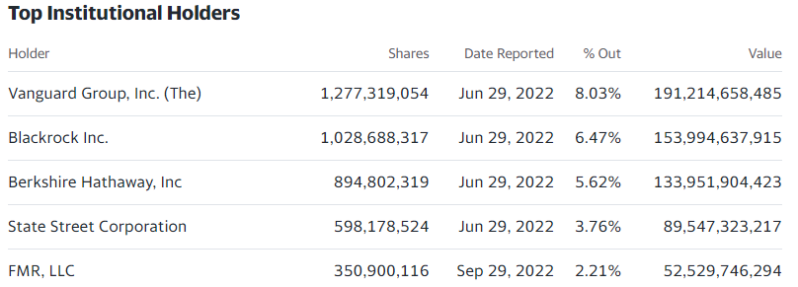
      * Above institutional investors can provide monitoring and corporate governance.
      * Above blockholders (owns more than 5% equity stake) can provide activism and more monitoring and corporate governance.
    - See, e.g., AAPL for board of directors:
      * <https://www.morningstar.com/stocks/xnas/aapl/executive>
      * 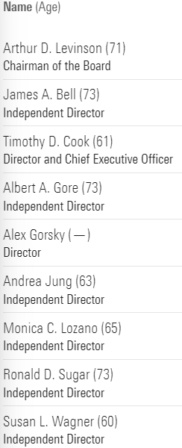
      * Timothy D. Cook services on the board of directors and is the CEO which may suggest weaker internal corporate governance. This situation with the CEO being a director is becoming more common. There is no CEO Duality problem because he is not a board chairman.
  + Financial Distress
    - Leverage Ratio

|  | 2022 | 2021 | 2020 | 2019 |
| --- | --- | --- | --- | --- |
| long term debt | 98,959,000.00 | 109,106,000.00 | 98,667,000.00 | 91,807,000.00 |
| equity | 50,672,000.00 | 63,090,000.00 | 65,339,000.00 | 90,488,000.00 |
| leverage ratio | 66.14% | 63.36% | 60.16% | 50.36% |

* + - * <https://finance.yahoo.com/quote/AAPL/balance-sheet?p=AAPL>
      * AAPL's leverage ratio is higher than the average leverage ratio of 20-30%. Importantly, AAPL's leverage ratio is higher than the critical threshold of 40%, suggesting a high risk of financial distress. The leverage ratio also reflects the firm’s capital structure.
      * Additionally, AAPL’s leverage ratio has increased over time, suggesting an increased risk of financial distress.
    - Liquidity Ratio
      * AAPL’s current ratio is 0.88 as of 9/30/2022.
      * <https://www.morningstar.com/stocks/xnas/aapl/valuation>
      * AAPL's current ratio is below US firms' average current ratio (2 - 2.5). AAPL's liquidity ratio is below the critical threshold of 1 to 1.25; this result does suggest the risk of distress and short-term liquidity problem.
      * Additionally, according to the ratio table provided earlier in this assignment, AAPL’s current ratio was 1.07 in the fiscal year 2021 (0.88 in 2022), which may suggest an increased risk of distress and liquidity problems.

**Step (3) Firm Valuation with Sensitivity Analyses**

* (3.A) Provide detailed, explicit discussions on all of the key assumptions:
  + Sales Growth Rate, Long‐Term Growth Rate, Beta, Cost of Capital, Reduction in Cap Exp, etc

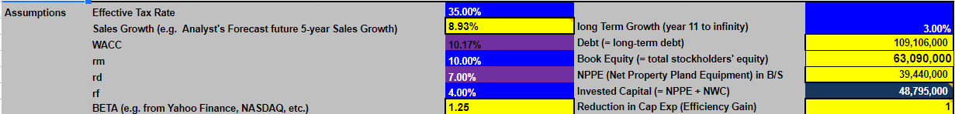

* + Discuss all of your valuation assumptions as clear as possible:
    - Source of information/input of valuation assumptions such as Sales Growth, Beta, etc.
      * Morningstar and yahoo finance.
    - Interpretation of the valuation assumptions
      * Sales growth: 8.93%
        + Analyst’s forecast future 5-year sales growth
      * WACC: 10.17%
        + WACC is the overall cost of capital to a firm after adjusting for tax savings.
        + WACC = (D/(D+E))* rD *(1- tc) + (E/(D+E))* rE
        + Discount rate
      * Rm: 10.00%
        + Market return
      * Rd: 7.00%
        + Corporate bond rate
      * Rf: 4.00%
        + Risk-free rate
      * Beta: 1.25
        + Stock is riskier than the overall market (average beta = 1).
        + High tech firms are considered high risk resulting in higher betas
      * Long-term growth: 3.00%
        + “Long-term growth rate” can be assumed as about 2% to 3% and should not be greater than 3% because this is the long-term, perpetual growth rate.
      * Debt: 109,106,000,000
        + Long-term debt
      * Book equity: 63,090,000,000
        + Total stockholders’ equity
      * NPPE: 39,440,000,000
        + Net Property Plant Equipment
      * Invested capital: 48,795,000,000
        + For Economic Profit valuation: Invested Capital = NPPE + NWC; NPPE and NWC (= Total Current Assets – Total Current Liabilities) are inputted from the Balance Sheet Statement.
      * Reduction in Cap Exp: 1
        + No reduction in projected Capital Expenditures in the future.
        + Efficiency gain
* (3.B) Provide detailed interpretations of the firm valuation results based on the FCF, RE, and EP valuation.
  + FCF Valuation

| **Present Value of the Firm** | **1,128,981,305.86** |
| --- | --- |
| **Shares Outstanding** | **15,910,000.00** |
| **Stock Price (based on FCF)** | **70.96** |
| **Current market price** | **$ 145.03** |

* + Economic Profit (EP) Valuation

| **Present Value of the Firm** | **785,750,595.41** |
| --- | --- |
| **Shares Outstanding** | **15,910,000.00** |
| **Stock Price (based on EP)** | **49.39** |
| **Current market price** | **$ 145.03** |

* + Residual Earnings (RE) Valuation

| **Present Value of the Firm** | **3,188,290,242.09** |
| --- | --- |
| **Shares Outstanding** | **15,910,000.00** |
| **Stock Price (based on RE)** | **200.40** |
| **Current market price** | **$ 145.03** |

Provided interpretation of the valuation results of FCF, RE and EP (vs. actual stock price)

Compare the estimated firm value per share vs. actual market price per share – under‐ or over‐valuation?

Note: See, e.g., Intrinsic Value (firm valuation) = V0 (CELL I 37 for FCF; CELL I 65 for RE; CELL I 52 for EP)

Market Value (stock price) = P0 (CELL I 38 or CELL 66 or CELL 5)

Examples of recommendations: P0 > V0 overvalued SELL P0 < V0 undervalued BUY

* + FCF
    - 145.03 > 70.96 → overvalued → SELL
  + EP
    - 145.03 > 49.39 → overvalued → SELL
  + RE
    - 145.03 < 200.40 → undervalued → BUY
  + Discuss any differences or similarities in estimated firm value per share based on the FCF vs. RE vs. EP models.
    - The estimated firm value per share for FCF and EP were both lower than the market value, resulting in an overvalued and sell recommendation.
    - The estimated firm value per share for RE was higher than market value, resulting in an undervalued and buy recommendation.
* (3.C) Provide Sensitivity Analyses for the results of firm valuations:
  + Sensitivity table with Reduction in Sales Growth:

|  | **Sales Growth** | **Firm Value Per Share (based on FCF)** |
| --- | --- | --- |
|  | -100% | **$ 8.38** |
|  | -80% | **$ 9.10** |
|  | -60% | **$ 10.28** |
|  | -40% | **$ 12.85** |
|  | -20% | **$ 20.53** |
|  | 0 | **$ 45.88** |
| base case | 9% | **$ 70.96** |
|  | 20% | **$ 125.22** |
|  | 40% | **$ 350.57** |
|  | 60% | **$ 931.62** |
|  | 80% | **$ 2,307.05** |
|  | 100% | **$ 5,332.55** |

* + - Interpretations:

| 1. Sales growth increases --> firm value increases |
| --- |
| 2. Sales growth increases from 20% to 40% --> firm increases by 179.96% (from $125.22 to $350.57) |

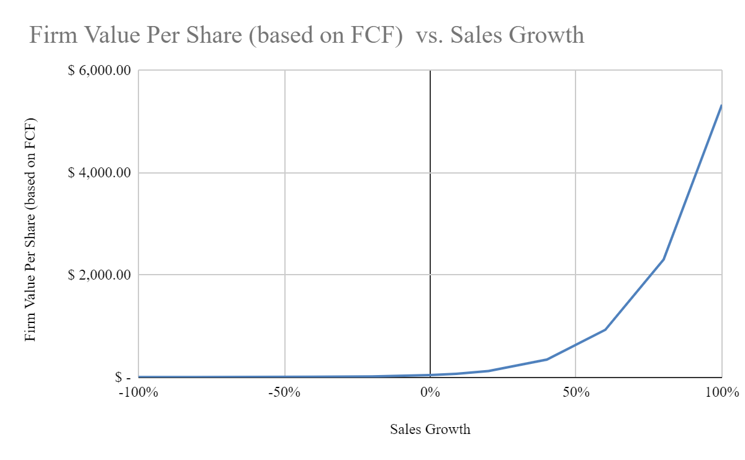

* + Sensitivity table with Reduction in Beta

|  | **Beta** | **Firm Value Per Share (based on FCF)** |
| --- | --- | --- |
|  | 0.2 | **$ 153.72** |
|  | 0.4 | **$ 124.96** |
|  | 0.6 | **$ 105.54** |
|  | 0.8 | **$ 91.94** |
|  | 1 | **$ 80.99** |
|  | 1.2 | **$ 72.76** |
| base case | 1.25 | **$ 70.96** |
|  | 1.4 | **$ 66.13** |
|  | 1.6 | **$ 60.72** |
|  | 1.8 | **$ 56.20** |
|  | 2 | **$ 52.37** |
|  | 2.2 | **$ 49.09** |
|  | 2.4 | **$ 46.25** |
|  | 2.6 | **$ 43.77** |
|  | 2.8 | **$ 41.57** |
|  | 3 | **$ 39.63** |

* + - Interpretations

| 1. Beta increases, firm value decreases |
| --- |
| 2. Beta increases from 1.6 to 1.8, firm value decreases by 7.44% (from $60.72 to $56.20) |

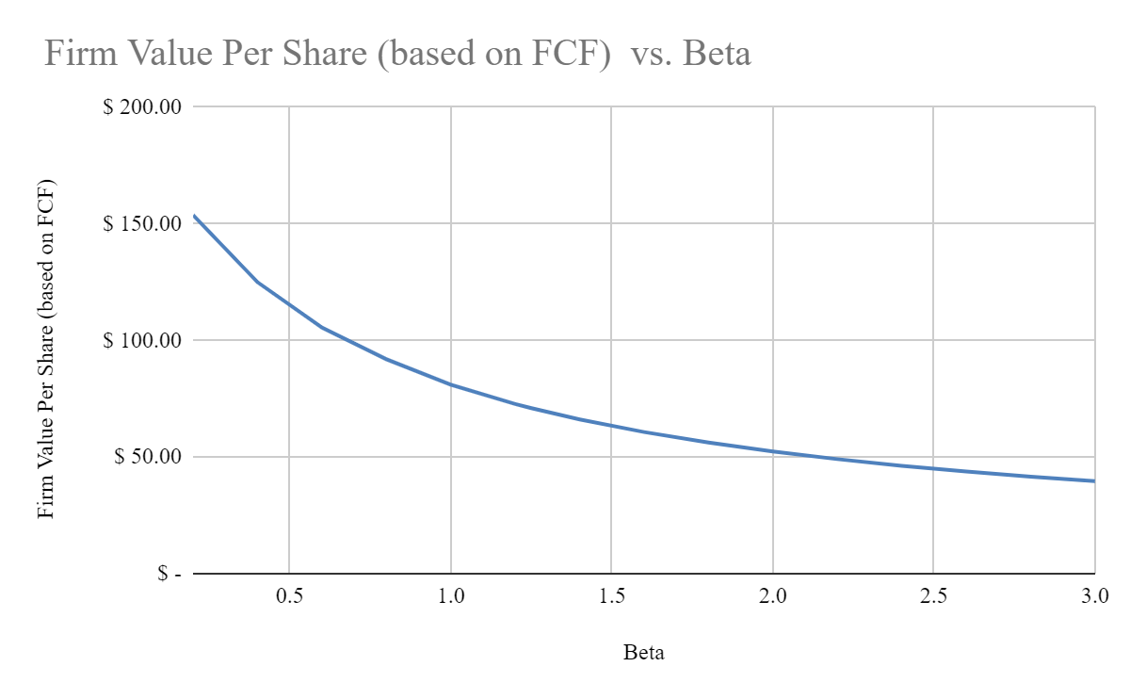

* + - Sensitivity table with Reduction in Cap Exp:

|  | **Cap Exp Reduction** | **Firm Value Per Share (based on FCF)** |
| --- | --- | --- |
| base case | 1 | **$ 70.96** |
|  | 0.8 | **$ 73.84** |
|  | 0.6 | **$ 76.71** |
|  | 0.4 | **$ 79.58** |
|  | 0.2 | **$ 82.46** |
|  | 0 | **$ 85.33** |

* + - Interpretations

| 1. If reduce capexp -> firm value increases |
| --- |
| 2. If capexp reduces to from 100% to 80% --> firm value increases by 4.06% (from $70.96 to $73.84) |

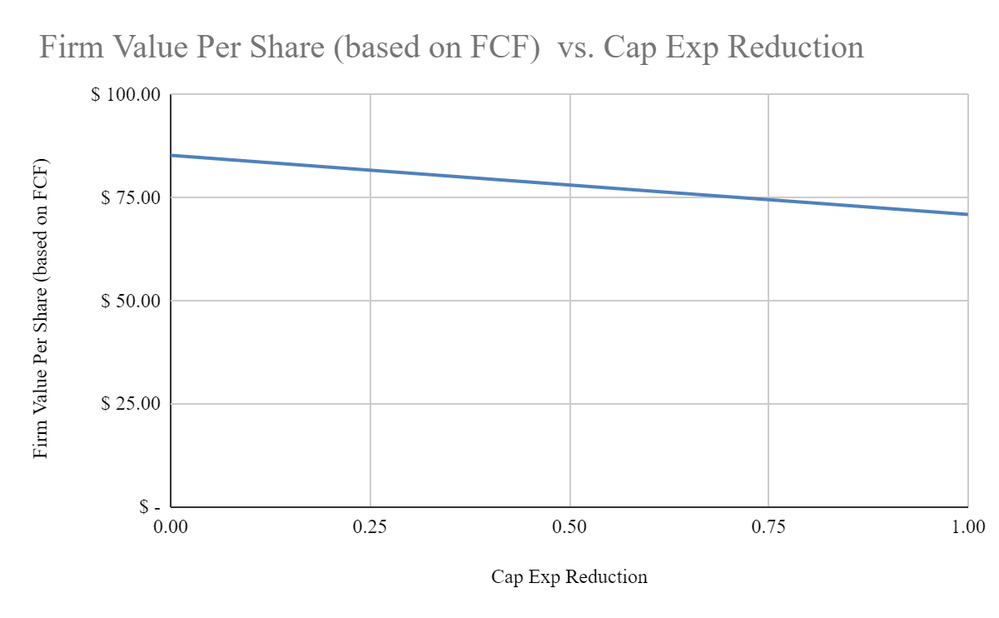

Additional Sensitivity/Scenario Analyses:

* Reverse‐engineering
* Sensitivity of EP: ROIC

| **Additional Sensitivity** | **EP Model** |
| --- | --- |
| **ROIC** | **This is Firm Value Per Share (based on EP valuation)** |
| 0% | error |
| 5% | -$69.25 |
| 10% | $1.88 |
| 15% | $25.59 |
| 20% | $37.45 |
| 25% | $44.56 |
| 30% | $49.30 |
| 30.11% (base) | $49.39 |

1. If ROIC increases, EP increases.
2. If ROIC increases from 15 to 20%, firm value increases by 46.34% (from $25.59 to $37.45)

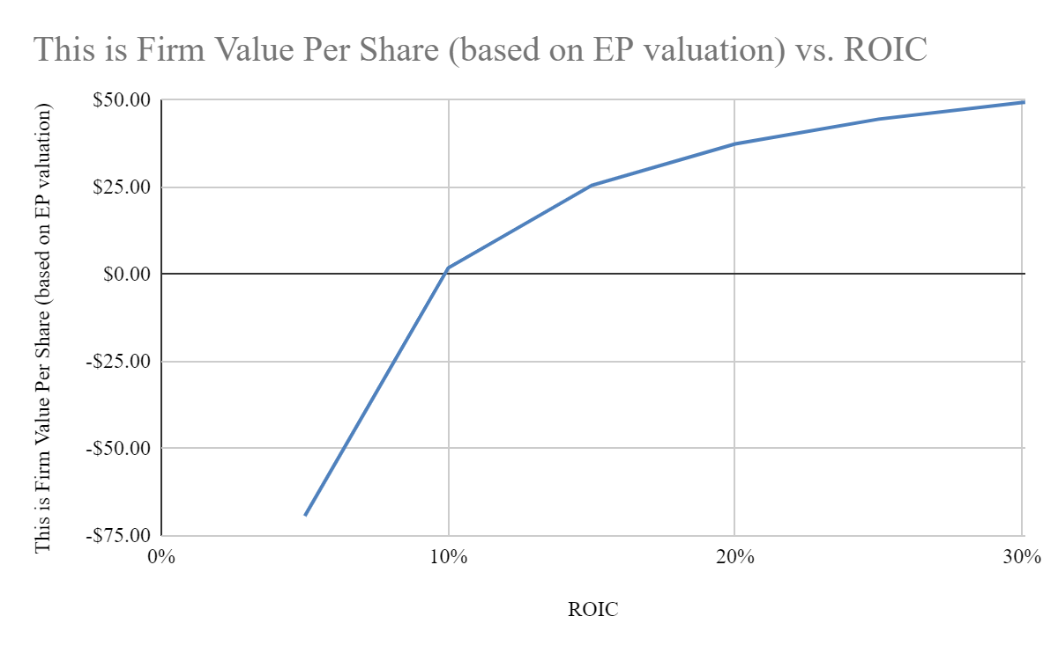

* Sensitivity of RE: ROE

| **Additional Sensitivity** | **RE Model** |
| --- | --- |
| **ROE** | **This is Firm Value Per Share (based on RE valuation)** |
| 0% | $1.35 |
| 5% | $3.75 |
| 10% | $6.14 |
| 15% | $17.75 |
| 20% | $33.31 |
| 25% | $48.87 |
| 30% | $64.43 |
| 73.69% (base) | $200.40 |

1. If ROE increases, RE increases.
2. If ROE increases from 5 to 10%, firm value increases by 63.73% (from $3.75 to $6.14)

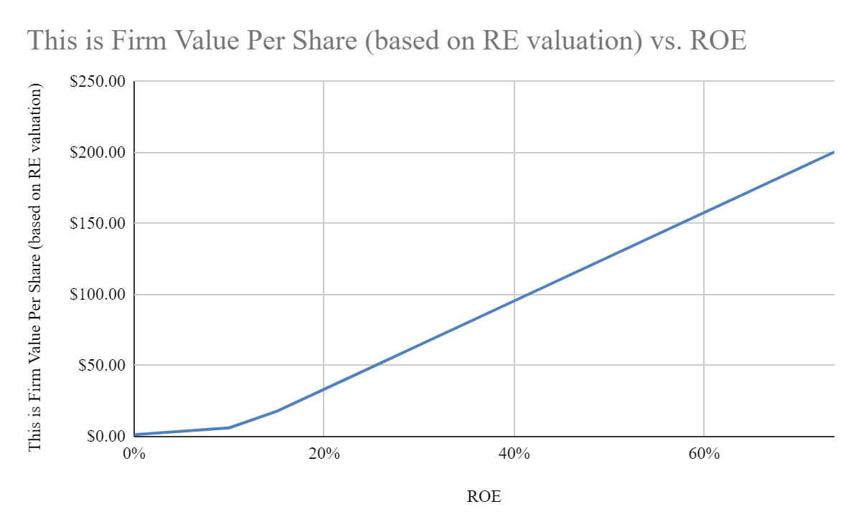

**Step (4) Policy Analysis and Stock Recommendations**

* (4A) Corporate Financing Decisions (with applications of Capital Structure Theories): Provide your own policy recommendations to corporate financing and capital structure decisions of this firm. Specifically, discuss whether this firm should follow (the following will be covered next class on Nov 12, 2022):
  + (I) Static Tradeoff Theory? Yes or no – explain the reasons.
    - No. While Apple is a mature, established firm, its leverage ratio is very high at 66.14% as of 9/30/2022, well above the average 20% - 30% and 40% critical value. They are at high risk for financial distress.
    - APV = 50,672,000,000 + 350,000 - 11,000,000 = 50,661,350,000
      * <https://finance.yahoo.com/quote/AAPL/balance-sheet?p=AAPL>
      * In the above formula, we used equity as of 9/30/22. We also assume Apple will pay the direct and indirect costs of financial distress.
      * The above further shows that Apple’s PV would decrease, supporting the decision not to engage in the static tradeoff theory.
  + (II) Pecking Order Theory? Yes or no – explain the reasons.
    - Depends. The CEO is also on the board of directors, which may suggest agency problems. If Apple uses more cash, it is not guaranteed that the managers will use the cash responsibly in the shareholders’ favor. However, using the pecking order would encourage managers to use the funds to reduce information asymmetry, lowering Apple’s already high information asymmetry. Conversely, not following the pecking order and going straight to equity payments would reduce agency problems and information asymmetry, which Apple is currently very high in both. Apple also already has many investors with eyes on the company and a few who can influence the company’s choices.
      * Answer would be Yes if their managers can be trusted, they are trained to make better decisions, and they are highly monitored to make better decisions.
      * Answer would be No if Apple is willing to pay more in dividends.
  + (III) Agency Theory of Debt? Yes or no – explain the reasons.
    - Depends. Having more debt to influence managers to make better decisions for the shareholders would be beneficial. However, Apple’s high risk for financial distress may exacerbate the issue while discouraging managers from making risky growth decisions. Apple is widely known to be an innovator, which may inadvertently hurt the company.
      * Answer would be Yes if managers can make good decisions for shareholders while also making good decisions for company innovations.
      * Answer would be No if any of the above is No.
* (4.B) Corporate Governance: Based on your own insight, recommend two (2) corporate financial policies that can improve corporate governance of this firm. Specifically, discuss your proposed corporate financial policies, which can improve corporate governance of this firm.
  + Agency theory would certainly improve corporate governance in the firm as the managers would be monitored more closely and issued more debt.
  + Pecking order could also work if Apple is willing to hold the managers more accountable for their spending. The institutional investors would also need to be trusted to monitor Apple appropriately.

**Step (5) Conclusion and Learning Outcomes**

* (5.A) As a financial analyst, what is your stock recommendation (i.e., buy/hold/sell/others) of this company? Explain and support your stock recommendation based on your results from financial analyses and firm valuation models (including sensitivity analysis) in Steps (1) to (4) above.
  + I would recommend buying the stock for several reasons. Their assets and free cash flow are increasing year by year. Their SGR indicates a high growth rate. Their ROA and ROE are in a great spot, and their forward P/E and P/B ratios are fantastic, even when compared to firms in similar market positions. Many institutional investors with blockholders will monitor the company to improve corporate governance. Also, their ROE is great in that it is undervalued and still has room for growth.
  + Further, discuss at least one (1) example of investment risks of this company.
    - Risks are potential agency problems and financial distress. However, management freedom may contribute to Apple's ability to innovate successfully and consistently. High institutional investor influence may be affecting management to use their power responsibly.
* (5.B) Two (2) most important findings that you have learned from your equity research and analyses/valuation of this company.
  + High information asymmetry, agency problems, and financial distress may not necessarily indicate that a company is not growing.
  + Having the right investors and quality managers can mitigate some issues and position a company to counter its inherent risks.

**INDIVIDUAL RESEARCH ASSIGNMENTS Part II. Stock Investment Simulation**

**Step (1) Statement of Investment Objectives and Stock Investment Plan**

* (1.A) Discuss your investment objectives and expected (target) rate of returns (%) to achieve during this simulation. Also, discuss what specific benchmark portfolio you use to evaluate your investment performance.
  + My goal is to have returned between 2% to 10%. The reason is that the S&P average is 10% per year, but 2 to 3% in class would be considered ‘good’ for us students in this simulation. I think aiming between good for our class and good for the market is achievable and reasonable for a beginner investor.
* (1.B) Discuss your sources of information, your risk aversion, and any constraints during the simulation.
  + My sources of information are what has been taught through yahoo finance and morningstar, the Nasdaq earnings schedule, my research into news and articles, and examples from successful investors.
  + Risk aversion, for me, is quite high. In the past, I have been suggested to avoid the stock market, and I have lost several thousand, not heeding the suggestion. I have so far been increasingly careful with my stock decisions. I am pretty scared of having big losses, so shorting is out of the question (even if certain news makes it seem like shorting would be the way to go). In this past class on Saturday, 11/12/2022, I took strong notice of the suggestion to invest in mutual funds, which are naturally less risky than stocks, and can still make good returns. I’ll look into that moving forward.
  + Constraints would be my interest and effort (with high interest and effort to behave like a day trader) and my skill and risk aversion. I’m still a beginner, so that would hold me back from any who already have experience in the stock market. Also, stocks are, by nature, risky investments. I’m risk-averse, so doing well in stocks is a nice challenge.

**Step (2) Stock Investment Strategies with Applications of Corporate Finance Theories and Financial Analyses**

(see homework #2 and homework #4)

Construct your equity investment strategies and select stocks in your portfolios based on your original insights, financial analyses, research findings, and applications of corporate finance theories.

* (2.A) Discuss how you construct your investment strategies and stock portfolios, including asset/stock selection (e.g., stock picking) in your portfolio. Discuss any unique features of your investments and trading strategies. Discuss the total number of trades you have completed. During the simulation, you should have completed at least Twenty Five (25) different trades to demonstrate different investments and trading strategies. Note: all of your trades should be performed no later than Friday, Dec 2, 2022.
  + At first, I went with recommendations from news articles and big investor portfolios. I would see which stocks were consistently recommended, then choose those. Coincidentally, one of those stocks was Apple (which I wanted to invest in any way since I chose this company). I then started to look at ROA and ROE and chose stocks based on good ratios. Over time, I began considering more ratios, such as payout, P/E, P/B, and beta. This led things to become more and more confusing because it was incredibly hard to find a stock that was good at all of the ratios. I did eventually find one (Visa). Interestingly, Qualcomm was also good in all ratios, but I was hesitant to buy because of the scheduled questionable earnings call. In hindsight, my knowledge would have been sufficient to short Qualcomm successfully, but my risk aversion constrained me from doing so.
  + As of today, 11/13/2022, I have done 10 trades, and am in 13th place at 3.74%. While I am definitely within my goal of 2 to 10%, I am still quite behind those far in advance of my returns. This compels me to try harder to make returns and either find a way to make more returns while still being risk-averse or start taking calculated risks (which I suppose I am already doing). I understand twenty-five (25) trades are needed. I will be researching more about mutual funds and taking bigger risks with the two weeks I have left for trading.
* (2.B) Explain how you perform portfolio diversification (e.g., across different stocks/assets, industries, and markets). Provide examples of how you achieve investment efficiency by applying the Efficient Frontier and Capital Market Line (CML) in your investment portfolio. (see homework #4)
  + I’ve attempted to diversify my portfolio by investing in different industries, such as Home Depot, Costco, and Amazon. While I will continue to do this, I want to try diversifying into mutual funds.
  + Efficient Frontier was applied when I invested in a passive market index portfolio: SPY. SSgA Active Trust - S&P 500 ETF TRUST ETF
    - QTY: 130
    - PRICE PAID: $381.71
  + CML was applied when I invested into risk-free assets: T-Notes, 2.75, 15112023.
  + Update 11/15/2022: I invested in SDY; SPDR Series Trust - SPDR Dividend ETF.
    - QTY: 388
    - PRICE PAID: $128.33
  + Also invested in three (3) mutual funds.
    - * 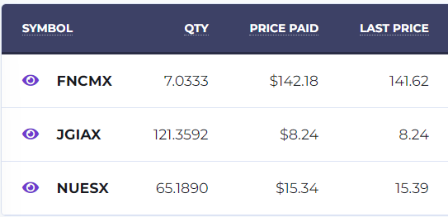
      * [9 Best Index Funds for Long-Term Investors | The Motley Fool](https://www.fool.com/investing/how-to-invest/index-funds/best-index-funds/)
  + Update 11/23/2022: I invested in XLF; SSgA Active Trust - Financial Select Sector SPDR (my 25th trade)
    - QTY: 1000
    - PRICE PAID: $35.86
* (2.C) Provide Three (3) different examples of stock trades (either “Buy/Long” position or “Sell/Short” position) that are supported by corporate finance theories (e.g., capital market imperfections) and financial analyses (e.g., financial ratios, Beta, and Free Cash Flow, etc.). (see homework #2)
  + Corporate finance theories (e.g., capital market imperfections)
  + Financial analyses (e.g., financial ratios such as ROA, ROE, payout ratio, Beta; and Free Cash Flow, etc.).
  + Important Instruction #1: Your trading strategies should be supported by finance theories, financial data, financial analyses, and analytical tools learned from this course. Perform your trades based on applications of financial analyses (e.g., financial ratios, Free Cash Flow, and Beta) and corporate finance theories (e.g., different market imperfections, etc.). You may start with financial ratios (e.g., ROA, ROE, payout ratio, etc.), Free Cash Flow, Beta, and market multiples (e.g., Forward P/E and P/B) as the basis for equity selection.
    - Visa (V): Visa was my stock chosen that was first recommended because of Warren Buffet’s portfolio (<https://www.buffett.online/en/portfolio/>) and also my analysis of their stock. On 10/31/2022 Halloween, I bought 251 shares of Visa stock at a market price of $207.16. They had great ratios: ROE of 40.88%, ROA of 14.61%, Payout Ratio of 21.43%, Beta of .95, FCF of $17,879,000,000.00, forward P/E of 21.01, and P/B of 11.47. All ratios are within or exceed the average, which implies high growth potential.
      * I was also suggested to look more into market timings. Visa is venturing further into the digital currency market, which empirically seems like the trend society is headings towards. The below article from Motley Fool says that Visa is inflation-proof because no matter what people buy, Visa will gain a percentage of profit from those goods anyway. Since we are potentially heading into a recession, having a stock that will do well during the recession seems smart.
      * [VISA Files NFT and Metaverse Trademarks (msn.com)](https://www.msn.com/en-us/money/companies/visa-files-nft-and-metaverse-trademarks/ar-AA13zIvc)
      * [Visa Shows Once Again Why It Is the Ultimate Inflation Hedge | The Motley Fool](https://www.fool.com/investing/2022/11/03/visa-shows-once-again-why-it-is-the-ultimate-infla/?source=eptyholnk0000202&utm_source=yahoo-host&utm_medium=feed&utm_campaign=article)
    - Apple (AAPL): I chose Apple stock because it’s my project company, but I can do a recap here and provide some more detail. Like Visa, I found Apple in Warren Buffet’s portfolio, which made me more confident that Apple is a good stock. On 10/06/2022, I bought 341 shares at $146.63. Today, 11/18/2022, the price is $151.29. However, if I had sold the shares on 10/28/2022, I would have profited the most at Apple’s peak this past month at $155.48. Perhaps unfortunately for me, I am practicing a “hold” strategy aiming for long-term growth. I am also reluctant to behave like a day trader to buy low, sell high, and all those skills. They had great ratios: ROE of 175.46%, ROA of 21.21%, Payout Ratio of 14.73%, Beta of 1.25, FCF of $111,443,000,000.00, forward P/E of 21.83, and P/B of 37.92. All ratios are within or exceed the average, which implies high growth potential (although the payout ratio is a little low).

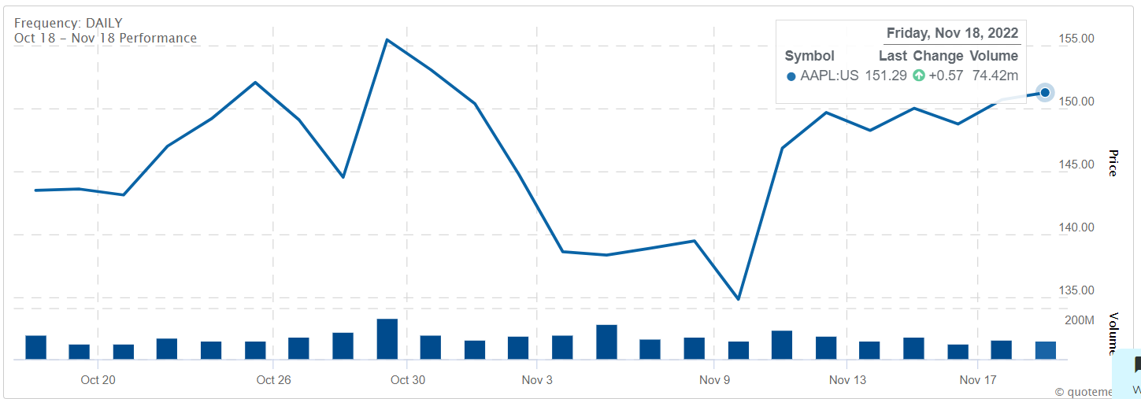

* + - * At the time, I did not consider market timing when buying stock, though I was aware that the iPhone 14 did come out recently. That large dip end of October may have been attributed to the iPhone 14 Plus ceasing in production due to low demand. And the covid restrictions in China beginning of November may have also attributed to the dip.
        + <https://www.firstpost.com/tech/news-analysis/iphone-14-plus-a-flop-apple-to-suspend-its-production-and-favour-iphone-14-pro-series-11484831.html>
        + <https://www.apple.com/newsroom/2022/11/update-on-supply-of-iphone-14-pro-and-iphone-14-pro-max/>
      * Regarding market imperfections: their high agency problems, high information asymmetry, and financial distress are usually signs of company issues; however, Apple is nonetheless still growing considerably. This taught me that even if a company is seemingly going through substantial capital market imperfections, that doesn’t mean the company is failing.
    - Taiwan Semiconductor Manufacturing Co. (TSM): On 11/18/2022, I bought 603 shares at $82.27 for two reasons.
      * One, the article linked below with Warren Buffet’s and morningstar’s recommendation (article date 11/16/2022) prompted me to look up the ratios and determine they are good. ROE of 36.57%, ROA of 15.36%, Payout Ratio of 32.20%, Beta of 1.15, FCF of $262,724,300,000.00 (as of 2021), FCF ttm of $511,698,560,000.00 (close to double since last year), forward P/E of 12.00 (a little below average), and P/B of 4.51.
      * Two, I have family in Taiwan and identify as Taiwanese (a bit of an emotional buy).
      * Taiwan Semiconductor Manufacturing Co. is the world’s largest dedicated chip manufacturer. It makes integrated circuits for customers based on its proprietary designs. TSMC's wide economic moat stems from its cost advantage and intangible assets, which are realized from its leading position in process technology or nodes. Projected for the company's top-line compound annual growth rate at 15.9% over the next five years. It is believed the company can deliver above-industry growth through a higher proportion of more valuable specialty products.
    - <https://finance.yahoo.com/quote/TSM?p=TSM&.tsrc=fin-srch>
    - <https://www.morningstar.com/stocks/xnys/tsm/quote>
    - <https://www.morningstar.com/articles/1125752/warren-buffett-thinks-tsmc-stock-is-a-buy-and-so-do-we>

**Step (3) Equity Trading Strategies Based on Corporate Finance Events**

Perform Three (3) different stock trading strategies based on actual corporate finance events. Discuss each of your corporate event-driven trades that you have performed in the simulation - with detailed information on specific timing, corporate news/event, and trading strategy. Discuss the strategic timing (i.e., the actual dates of your trades and dates of the news/announcements/events) as clearly as possible.

Major corporate news/events for equity trading strategies may include the following: earnings announcements, equity/debt offering announcements, dividends announcements, corporate restructuring, M&As, CEO turnover, and other corporate events that may affect firm value and performance.

* + Importantly, your equity trading strategies based on corporate news/events should be carefully discussed and supported by corporate finance theories. Important Instruction: Perform your stock trades with market timing of major corporate finance news/events/announcements such as earnings, dividends, M&A, financial distress, CEO turnover, change in corporate governance/control, etc. In your report, discuss the details and strategic timing of your stock trades based on corporate finance events as clear as possible.
  + Suggestions: The followings provide useful resources of corporate financial events and information for your stock trades: Earnings calendar: https://www.nasdaq.com/earnings/earnings-calendar.aspx Market activities: https://www.nasdaq.com/markets/ Dividend calendar and history: https://www.nasdaq.com/dividend-stocks/

1. Walmart (WMT)
   1. Date trades made: 11/14/2022 (ahead of earnings call on 11/15/2022)
   2. Listing price: $140.44
   3. Shares: 356
   4. According to the earnings report date below, Walmart’s forecasted EPS was 1.32, with the EPS after earnings at 1.5–a 13.64% surprise.

## **Quarterly Earnings Surprise Amount**

| **Fiscal Quarter End** | **Date Reported** | **Earnings Per Share\*** | **Consensus EPS* Forecast** | **% Surprise** |
| --- | --- | --- | --- | --- |
| **Oct 2022** | 11/15/2022 | 1.5 | 1.32 | 13.64 |

* 1. Summary: $3.56 billion in Q4 vs. -$2.09 billion in the same period last year.
     1. EPS: $1.28 in Q4 vs. -$0.74 in the same period last year.
     2. Excluding items, Walmart Inc. reported adjusted earnings of $1.53 per share for the period.
     3. Analysts projected $1.50 per share Revenue: $152.87 billion in Q4 vs. $152.08 billion in the same period last year.
  2. Due to my analysis prior to the earnings call, I concluded that Walmart would beat earnings and jump in price.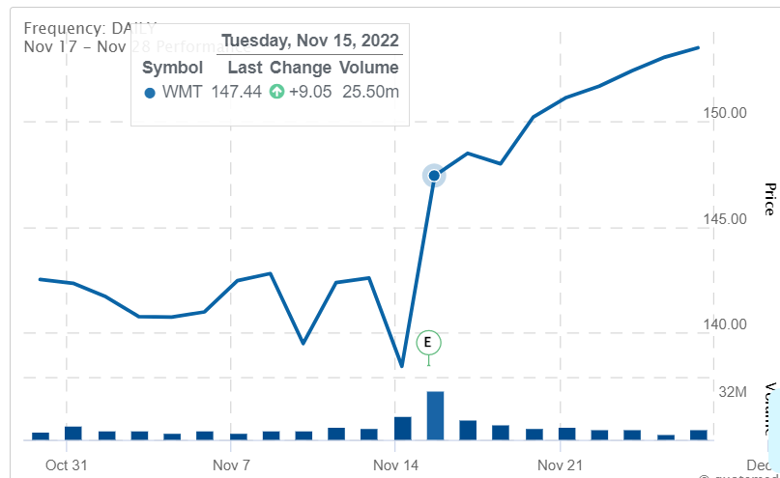
  3. After my investment on Nov 14, the stock increased by +9.05 on Nov 15 and is still increasing (something to do with the Holiday season?).
  4. [Walmart Inc. Common Stock (WMT) Earnings Report Date | Nasdaq](https://www.nasdaq.com/market-activity/stocks/wmt/earnings)
  5. [Walmart (WMT) Tops Q3 Earnings and Revenue Estimates (yahoo.com)](https://news.yahoo.com/walmart-wmt-tops-q3-earnings-132501834.html)

1. Taiwan Semiconductor Manufacturing (TSM)
   1. Date trades made: 11/18/2022 (when the Warren Buffet article came out posted for problem 2.C. Reposting here for convenience: <https://www.morningstar.com/articles/1125752/warren-buffett-thinks-tsmc-stock-is-a-buy-and-so-do-we>)
   2. Listing price: $82.27
   3. Shares: 603
   4. 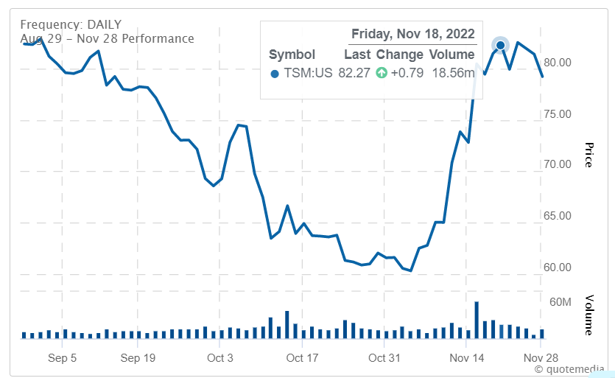
   5. From what I have experienced so far, buying into TSM was a mistake, as there has not been much growth in the past week or so. That might have been a better idea if I had invested at the beginning of November. However, I decided to look up another article (see below) that encourages stock buying. From what it looks like, Warren Buffet’s $4.1 billion investment in TSM is over the long haul, not for short-term gains. Annual growth is around 55%, forward P/E is estimated to be 13x, and there are also implications of a 21.4% upside potential.
   6. The difference between Walmart and TSM is that for Walmart, I was looking at their earnings for an immediate decision of whether the stock will go up or down. Warren Buffet sees way beyond that, which adds significant credibility to TSM's rising stock price over the long term. This also makes me happy (emotionally because of the family) and hopeful that Warren Buffet is correct. It’s nice to think that a country I identify with may become more successful far into the future.
   7. <https://www.nasdaq.com/articles/warren-buffett-buys-taiwan-semiconductor-stock-nyse:tsm.-should-you>
2. JD.com (JD)
   1. Date trades made: 11/17/2022 (ahead of earnings call on 11/18/2022)
   2. Listing price: $57.48
   3. Shares: 842
   4. 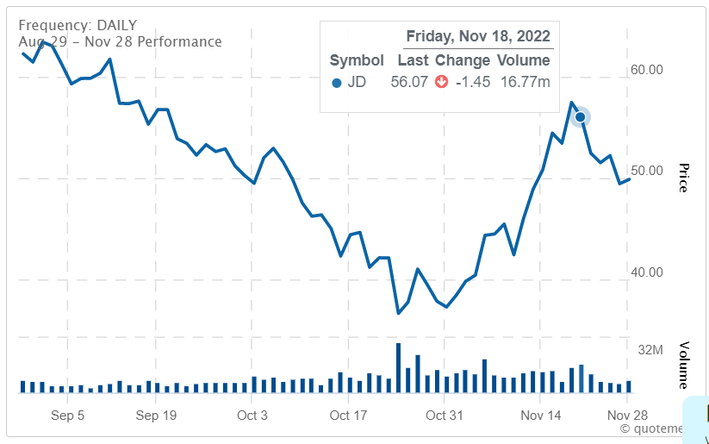
   5. I regret this one. The Nasdaq earnings announcement looked great (see below). They were listed as having high EQR, their forecasted EPS (.52) was higher than their last quarter EPS (.49), and their stock had been rising since the beginning of October. They even beat their earnings. From the article below, it looks like China is struggling due to covid lockdowns resulting in supply chain and logistics issues. Alibaba and Tencent also suffered losses because of external challenges. I suppose I should have taken the news of the resurgence of covid in China as important corporate finance news that could negatively affect stock market prices. China’s zero-covid policy encourages mass testing in various cities, with Foxconn (a massive factory producing iPhones) halting production due to staged protests. Perhaps AAPL was affected as well?
   6. 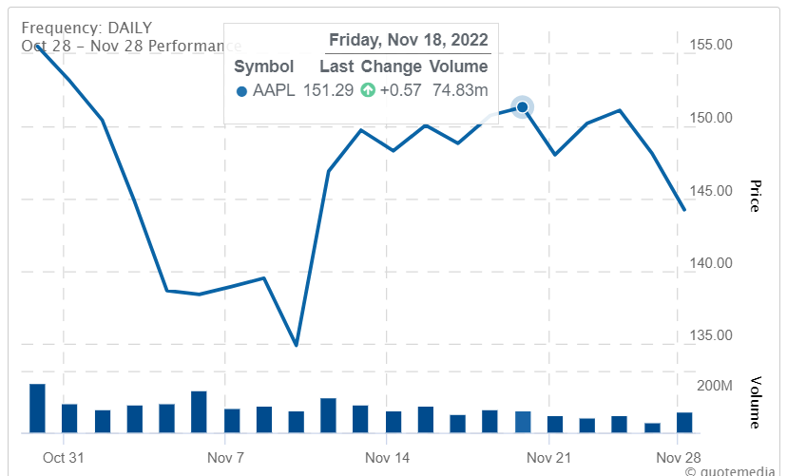
   7. Looking at the above graph, it seems AAPL may have also been affected negatively by the problems arising in China.
   8. <https://www.reuters.com/world/china/chinas-daily-covid-cases-hit-record-high-2022-11-24/>
   9. <https://www.investors.com/news/technology/jd-stock-china-ecommerce-firm-posts-mixed-q3-results/>
   10. <https://www.nasdaq.com/market-activity/stocks/jd/earnings>

**Step (4) Performance Evaluation, Learning Outcomes and Conclusion**

(4.A) Evaluate and discuss your investment performance with respect to the following performance criteria: (i) returns/profits, (ii) Sharpe ratio, and (iii) Alpha. Also, present your investment portfolio performance against market benchmark (using “Graph My Portfolio” in StockTrak).

* As of 11/28/2022:
  + My returns are at 3.08%
    - For our stock track class, 2-3% was the expected percentage of returns for this simulation. I am above that by .08%, so I have exceeded expectations (by a minuscule amount). Too many people have much higher returns than I do, which does make sense since I am a beginner at all this and some of the higher earners are more veterans at stock trading. I might have done better if I traded more often, but I intentionally tried to avoid that to not build the habits of a day trader. I am a buy-and-hold guy.
  + My Sharpe ratio is at 2.37
    - I remember in class that anything above 2.00 is considered good (for mutual fund managers). I think I did better here because I invested in several mutual funds due to their inherent safety as opposed to the less safe nature of stocks. Little concerned as I see those with a high Sharpe ratio in addition to high Alpha.
  + My Alpha is at .07%
    - Anything greater than zero means an investment outperformed after adjusting for volatility. This would mean that my investments are better than the market, although only slightly. I have spoken with Benny, our top Alpha hedge fund manager, and he said (maybe jokingly?) that he did a lot of shorting to get such a high Alpha. Regrettably, I did no shorting because I was too scared (a non-alpha trait, perhaps?). Makes sense, I suppose. I prioritized making safe bets as opposed to risky, high-stakes bets. My Alpha could use some raising, so it is something I can work to increase.
    - <https://www.investopedia.com/articles/investing/092115/alpha-and-beta-beginners.asp>

(4.B) Discuss your “best” stock trade, and explain why this example is considered as your best stock trade. In contrast, discuss your “worst” stock trade during the simulation, and explain why this example is considered as your worst stock trade.

* Best
  + My best stock is SPG, with a P/L of 8,595.00 and P/L % of 17.44%. I’ve heard many good things about REIT stocks, and their ratios may have alluded to the success of their stock. ROE of 67.74 and payout ratio of 101.40%. Since buying 500 shares of this stock at $98.31 on 10/20/2022, holding this stock has proved worthwhile. Maybe I should invest in more REITs?
* Worst
  + My worse stock is JD.com, with a P/L of -6,407.62 and P/L % of -13.23%. I elaborated above in Step (3). On paper, the stock looked promising, but Covid, unfortunately for me, had other plans. I should have foreseen the issues and sold (or shorted) JD.com. However, my faithful nature in Chinese stocks eventually increasing is compelling me to hold in hopes of a better future.

(4.C) Provide a concluding section to discuss the following: Two (2) major lessons or skills that you have learned from your trades and participations in this stock investment simulation.

* One
  + Research more news that may not be obviously relevant to stock price. Announcements, M&As, restructuring, and so on are prime examples of corporate news that can influence valuation. Even so, something such as a pandemic could highly influence stock price even when it isn’t obvious on the surface.
* Two
  + Diversify your portfolio. Trade in a variety of investments. Stocks (various industries), mutual funds, and bonds can all help with diversifying your portfolio without falling into the “all eggs in one basket” pit. Any losses don’t feel as painful since there are other stocks that can also increase due to things going well in that sector. Of course, if the whole market goes down, then I am in trouble (unless I learn better to sell and short).
* Three
  + Just wanted to add this one, which is to not get too emotional. Mistakes with choosing a stock, and buying and selling inappropriately will happen more often. I’ve also had some bad experiences with trading many years ago and was suggested to stay away from it, so I am apprehensive about getting too into trading. Regardless, I still wanted to learn about trading for my own knowledge and growth. Perhaps I’ll become more open to trading over time as I feel more stable with stocks.